## Self-Forgiveness

By: Tamicka Monson

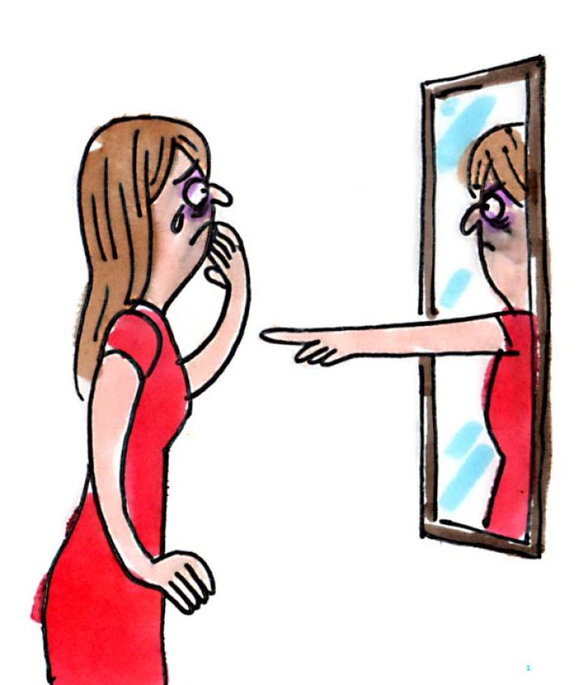

# Obstacles to Self-Forgiveness:

* Negative self-judgment
* Self-blaming
* A need to “be good” or seen as good
* Shame (which leads to other problems like perfectionism or self-destructive behaviors)

# Four Avenues to Self-Forgiveness:

|  |  |
| --- | --- |
| Self-Understanding | 1. Recognize the hurts and/or traumas in your life that led to your behavior. |
| Common Humanity | 2. Recognize your mistakes and how you have hurt others. |
| Taking Responsibility, Apologizing, and Making Amends | 3. Hold yourself accountable when you hurt others. Feel guilty without dwelling (i.e. rumination). |
| Asking For Forgiveness | 4. Give a sincere apology: admit regret, accept responsibility, and rectify the situation. Amend your mistakes. Focus on what you learned. Cultivate empathy for the victim. |

**Sources**:

Breines, J. (2012, August 23). The healthy way to forgive yourself.

<https://greatergood.berkeley.edu/article/item/the_healthy_way_to_forgive_yourself>

Cherry, K. (2019, August 5). How to forgive yourself.

<https://www.verywellmind.com/how-to-forgive-yourself-4583819>

Engel, B. (2017, June 1). Healing your shame and guilt through self-forgiveness.

from <https://www.psychologytoday.com/us/blog/the-compassion-chronicles/201706/healing-your-shame-and-guilt-through-self-forgiveness>